Austin Smothers

CISP 430

Assignment 1
RUNTIME PROGRAM

//Austin Smothers
//CISP 430
//Assignment 1
//September 5, 2017

//This program builds on code provided by Professor Ross

// HEADER FILE INCLUSION BLOCK
#include <iostream>
using namespace std;

// GLOBAL FUNCTION DECLARATION BLOCK
int foo1(int n);
int foo2(int n);
int foo3(int n);
int foo4(int n);

// MAIN FUNCTION BLOCK
int main(void)
{
/* n declared as a non global variable for... ummm... security reasons!
n declared as a const variable to make sure run time is solely based on
modified counters, not modified n's*/
const int n = 16;

//foo1 - foo4 output
cout << "Foo1 run time: " << foo1(n) << "\n";
cout << "Foo2 run time: " << foo2(n) << "\n";
cout << "Foo3 run time: " << foo3(n) << "\n";
cout << "Foo4 run time: " << foo4(n) << "\n";

return 0;
}

// GLOBAL FUNCTION DEFINITION BLOCK

//Foo1 looks like a basic N function
int foo1(int n)
{
int counter = 0;

for (int i = 0; i < n; i++)
counter++;

return counter;
}

//Foo2 looks like an N^2 function
int foo2(int n)
{
int counter = 0;

for (int i = 0; i < n; i++)
for (int j = 0; j < n; j++)
counter++;

return counter;
}

//Foo3 looks like a logN runtime function
int foo3(int n)
{
int counter = 0;

for (int i = n; i > 0; i = i/2)
counter++;

return counter;
}

//Foo4 looks like a 2^N runtime function
int foo4(int n)
{
/*nifty trick so you dont have to keep changing the value of counter
as this function recursively iterates*/
static int counter = 0;
counter++;

if (n > 0)
{
foo4(n - 1);
foo4(n - 1);
}

return counter;
}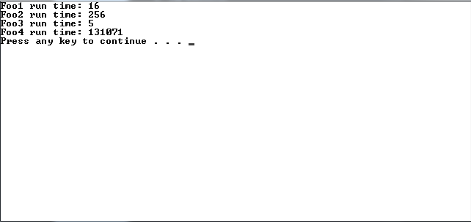

CODE ANALYSIS PROGRAM

//Austin Smothers
//CISP 430
//September 5, 2017

//This program builds on code provided by Professor Ross

// HEADER FILE DECLARATION BLOCK
#include <iostream>
using namespace std;

// GLOBAL FUNCTION DECLARATION BLOCK
int Arithmetic(int n)
{
int sum = 0;

for (int i = 1; i <= n; i++)
sum = sum + i;

return sum;
}

int Geom(int n, int A)
{
int term = 0;
int sum = 0;

for (int i = 1; i <= n; i++)
{
term = A;
for (int j = 1; j < i; j++)
term = term * A;
sum = sum + term;
}

return sum;
}

/*"Optimized" by replacing the second for loop with an if statement
I really don't think it decreases run time as it serves the same function as the old
for loop AND sends the computer through the same total number of processes...
but according to lecture notes this is supposed to be better*/
int GeomOP(int n, int A)
{
int term = 0;
int sum = 0;
int i = 0;
i++;
term = A;

for (int j = 1; j <= i; j++)
{
if ((i == j) && (i <= n))
{
j = 1; //reset j so that the for loop restarts after this statement is iterated
sum = sum + term;
term = A;
i++;
}
term = term * A;
}

return sum;
}

/*The same as the Geom code, but before adding sum = sum + term
since at that point, term represents the value of the specific number at A^n*/
int Other(int n, int A)
{
int term = 0;
int sum = 0;
int i = 0;
i++;
term = A;

for (int j = 1; j <= i; j++)
{
if ((i == j) && (i <= n))
{
j = 1;
term = term * i;
sum = sum + term;
term = A;
i++;
}
term = term * A;
}

return sum;
}
// MAIN FUNCTION BLOCK
int main()
{
const int n = 5;
const int A = 5;

/*Arithmetic calls/outputs
cout << "Arithmetic: " << Arithmetic(n) << "\n";*/

/*Geom, GeomOP, and Other calls/outputs*/
cout << "N = " << n << endl <<
"A = " << A << endl <<
"Geom: " << Geom(n, A) << endl <<
"GeomOP: " << GeomOP(n, A) << endl <<
"Other: " << Other(n, A) << endl;

return 0;
}
